목차

1. 애플리케이션 기획

* 게임 설명

1. High Level Design
2. Low Level Design

* 패킷

**High Level Design**

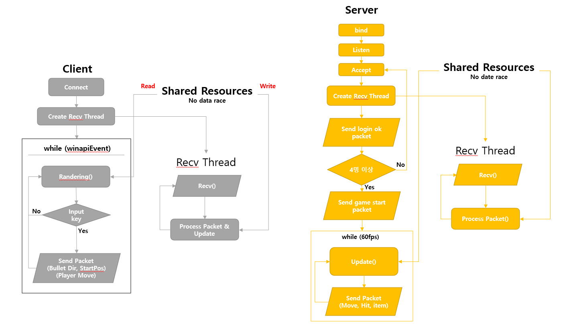

**Low Level Design**

1. **Protocol**

* 서버 주소

const short SEVER_PORT = 4000;

const char SEVER_ADDR = “127.0.0.1”;

* 총 종류

const char 1 = 0; // 피스톨

const char 2 = 1; // Uzi

const char 3 = 2; // 샷건

* 최대 접속 가능 클라이언트

const char MAX_USER = 4;

* 플레이어 상태

총, 이동, idle, hit

* 총알 발사 방향

const char DIR ///

* 패킷 타입 (Client -> Server)

const char CS_PACKET_LOGIN

플레이어 스킨

const char CS_PACKET_MOVE = 2;

플레이어 좌표, 방향

Const char CS_PACKET_PALYER_STATE

플레이어 상태 (idle, hit, run, shoot, die)

const char CS_PACKET_SHOOT_BULLET = 3;

총알 발사 방향, 시작 위치

const char CS_PACKET_ITEM =4

아이템 종류 (물약, 총 종류)

* 패킷 타입 (Server -> Client)

const char SC_PACKET_LOGIN_OK = 1;

클라이언트 id, 플레이어 좌표

Const char SC_CHANGE_SCENE

다음 씬 종류,

const char SC_PACKET_OBJ_MOVE = 2;

id, 방향, 위치

const char SC_PACHET_PLAYER_STATE

Id, 플레이어 상태 (idle, hit, run, shoot, die)

const char SC_PACKET_PUT_OBJ = 4;

id, 좌표

const char SC_PACKET_REMOVE_OBJ = 5;

id

// const char SC_PACKET_COLLISION = 6;

const char SC_PACKET_CHANGE_HP

id, hp 값

const char SC_PACKET_GET_ITEM = 7;

id, 아이템 종류 (물약, 총 종류)

const char SC_PACKET_CHAGE_WEAPON

id, 총 종류

패킷 정의(Client -> Server)

struct cs_packet_login{

unsigned char packetSize;

char packetType;

char playerType;

}

struct cs_packet_move{

unsigned char packetSize;

char packetType;

char x, y;

char dir;

char status;

}

struct cs_packet_shoot_bullet{

unsigned char packetSize;

char packetType;

char shootX, shootY;

char dir;

}

* 패킷 정의(Server -> Client)

struct sc_packet_login_ok{

unsigned char size;

char type;

char clientID;

char x, y;

}

struct sc_packet_player_move{

unsigned char size;

char type;

char clientID;

char x, y;

}

struct sc_packet_obj_move{

unsigned char size;

char type;

char clientID;

char objectType;

char x, y;

}

struct sc_packet_put_obj {

unsigned char size;

char type;

char clientID;

char objectType;

char x, y;

}

struct sc_packet_remove_obj {

unsigned char size;

char type;

char clientID;

char objectType;}

struct sc_packet_hit {

unsigned char size;

char type;

char clientID;

char objectType;

}

struct sc_packet_item {

unsigned char size;

char type;

…

}

1. **Client Method**

* **ProcessPacket()**

**패킷확인,**